“Month-Year” feature engineering step

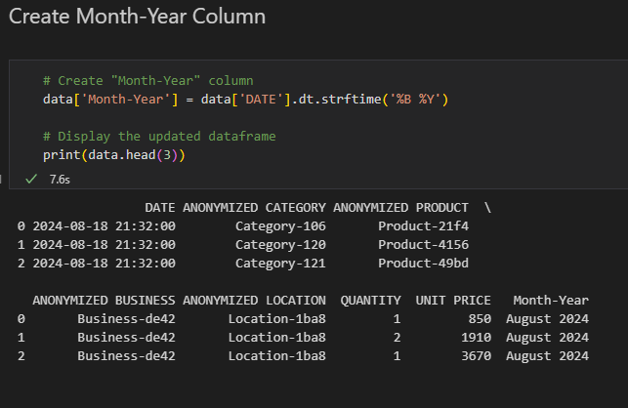

Dashboard Screenshots



